Dalton Murray

Lab 3

**Part 1**

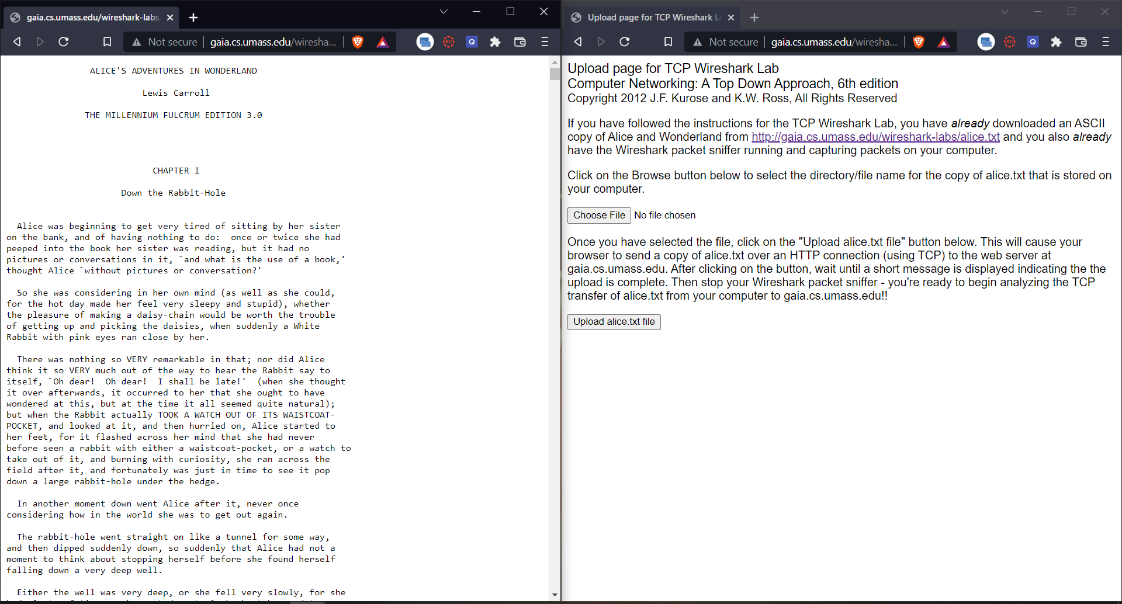

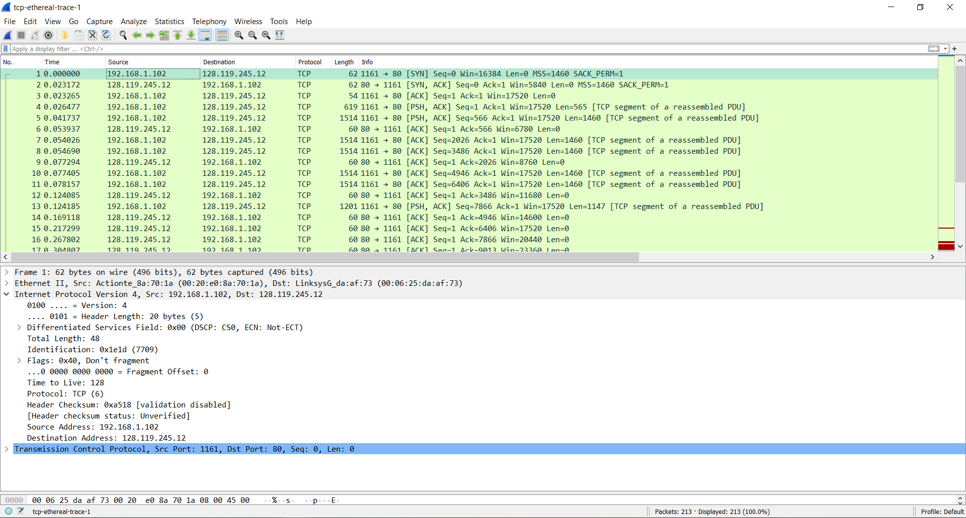

**Part 2**

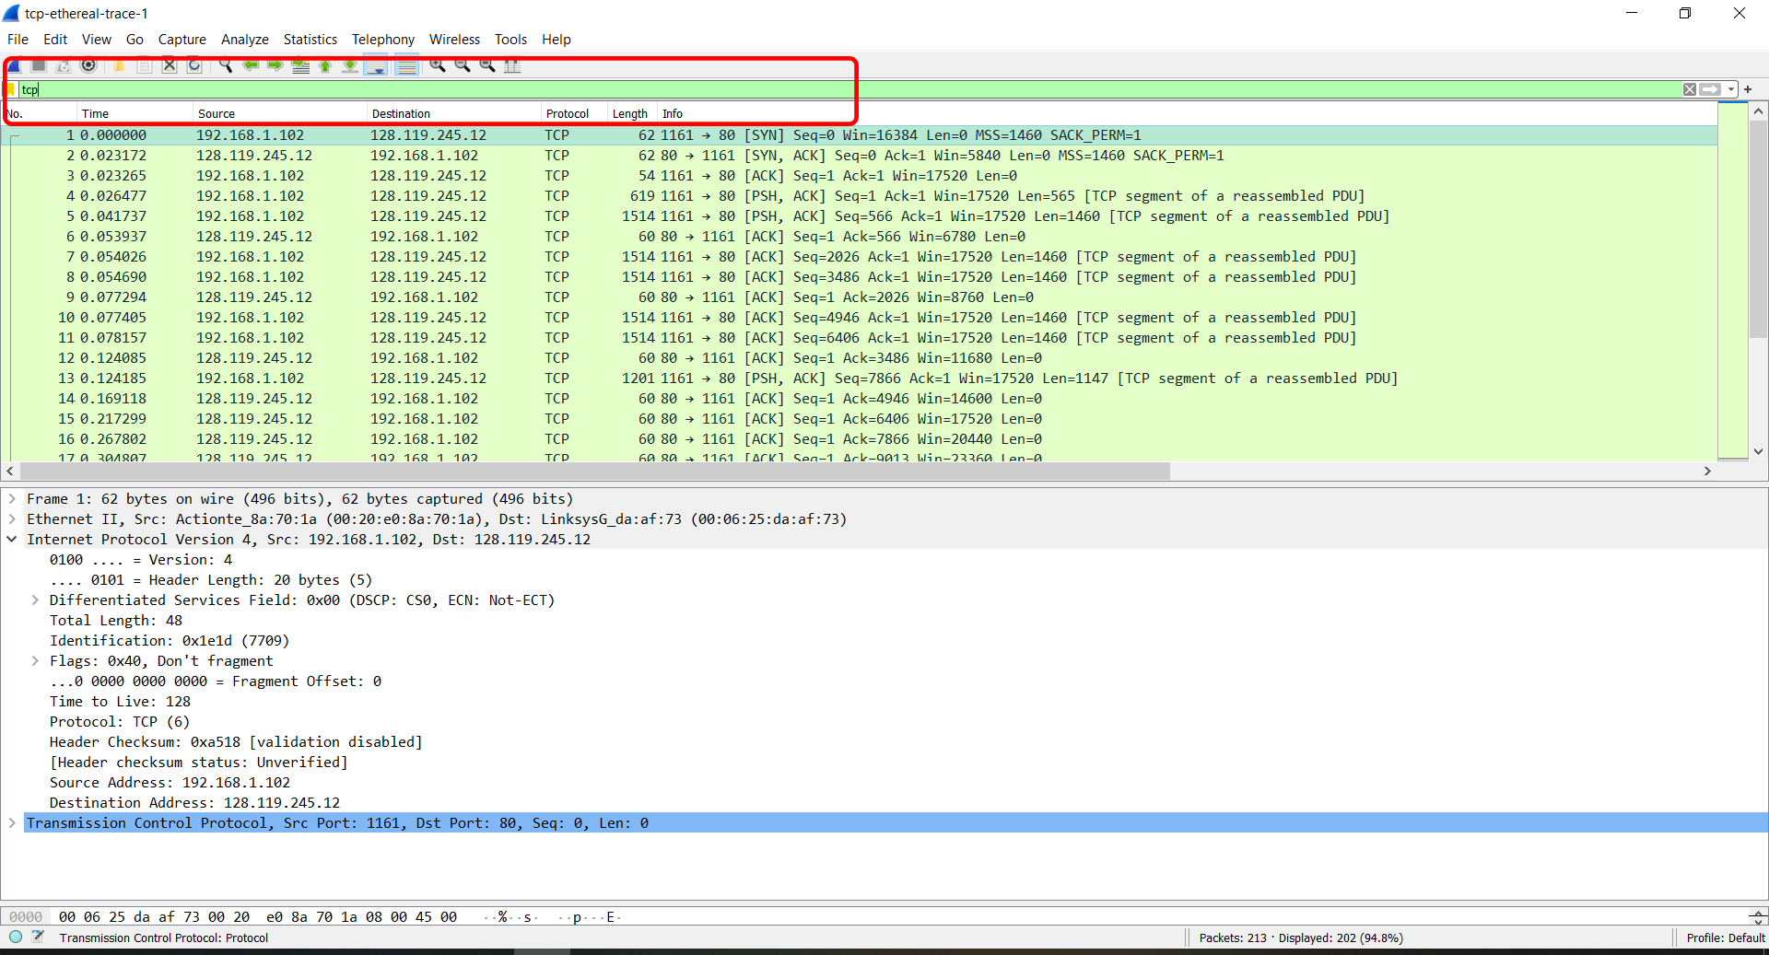

1. **What is the IP address and TCP port number used by the client computer (source) that is transferring the file to gaia.cs.umas.edu? To answer this question, it’s probably easiest to select an HTTP message and explore the details of the TCP packet used to carry this HTTP message, using the “details” of the selected packet header window.”**

IP address (source): 192.168.1.102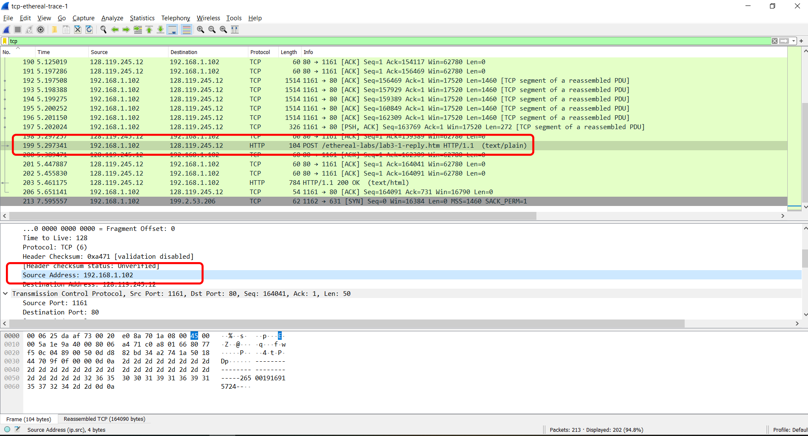

TCP port (source): 1161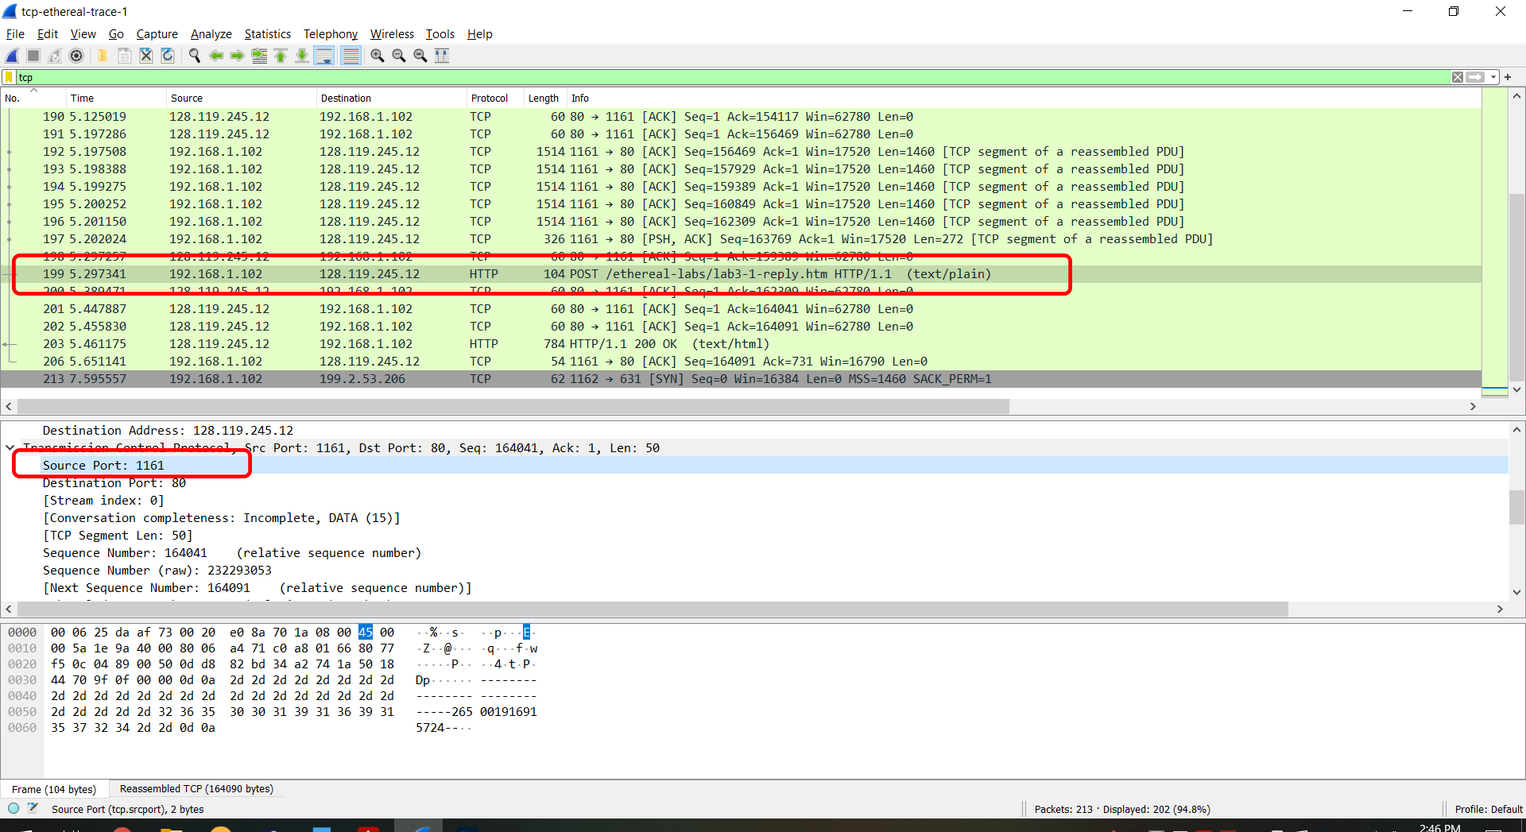

1. **What is the IP address of gaia.cs.umass.edu? On what port number is it sending and receiving TCP segments for this connection?**

IP (gaia.cs.umass.edu): 128.119.245.12

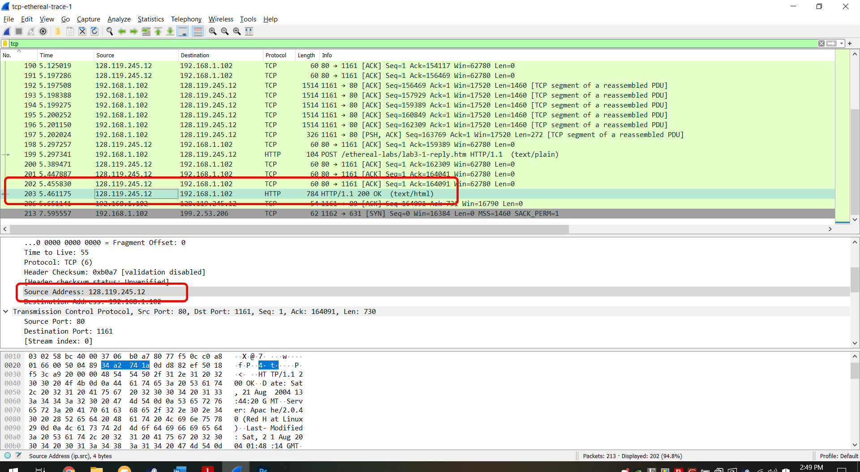

Port: 80

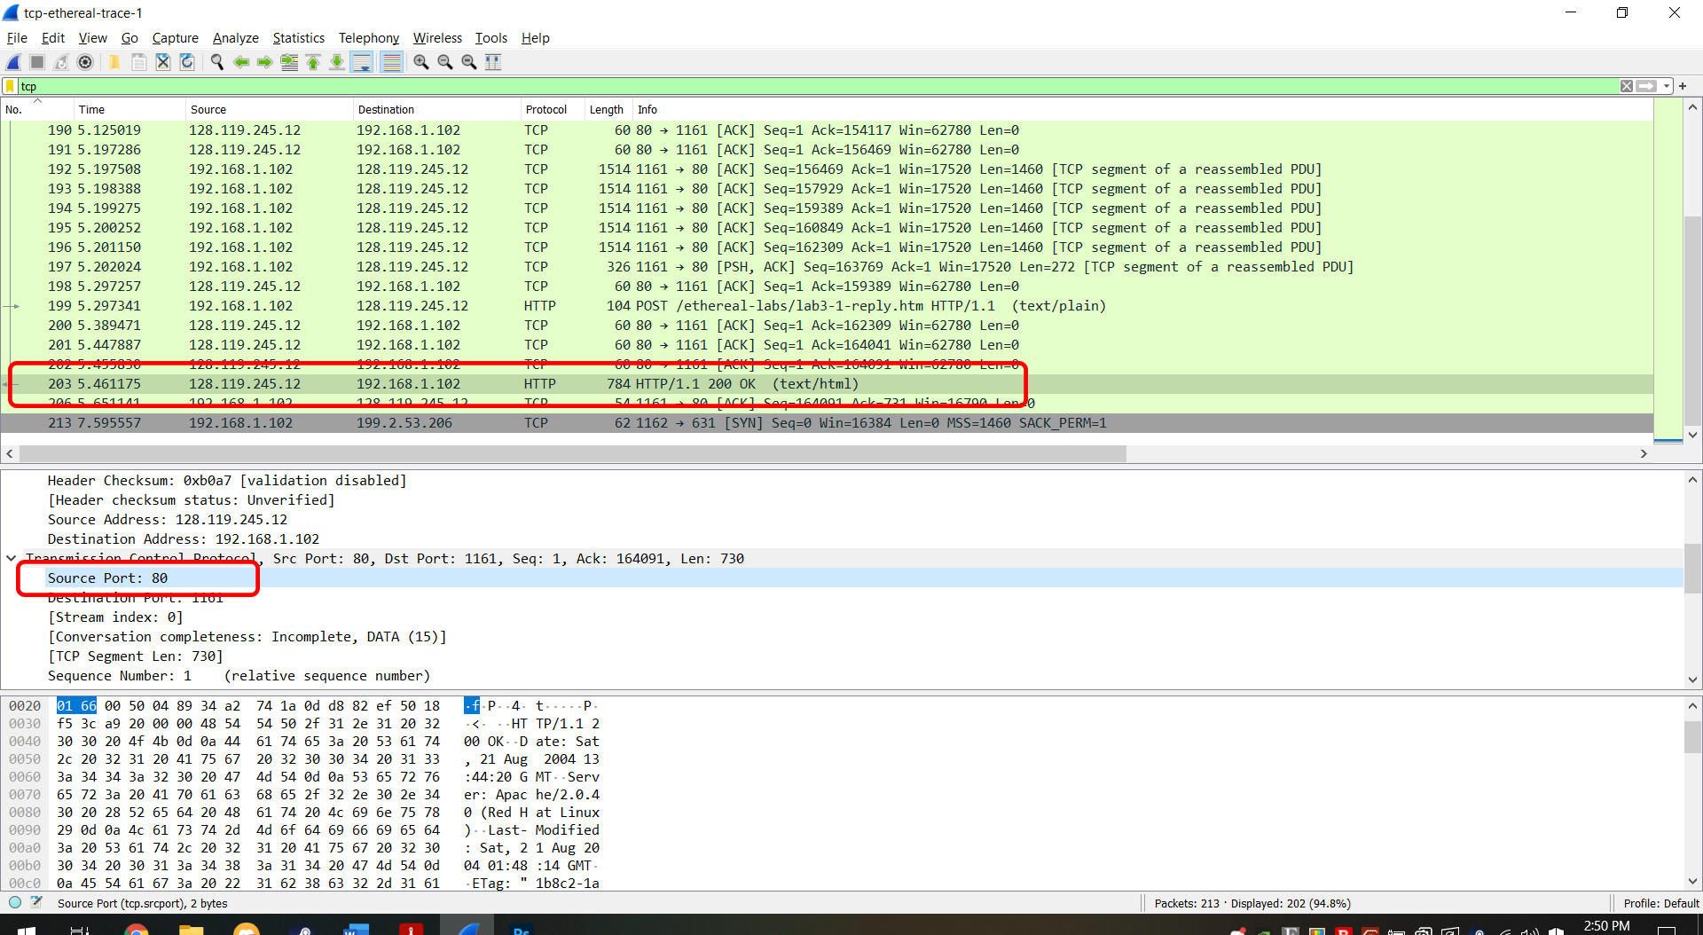

1. **If you have been able to create your own trace, answer the following question: What is the IP address and TCP port number used by your client computer (source) to transfer the file to gaiacs.umass.edu?**

Unable to create a trace in current environment.

Analyze -> Enabled protocols

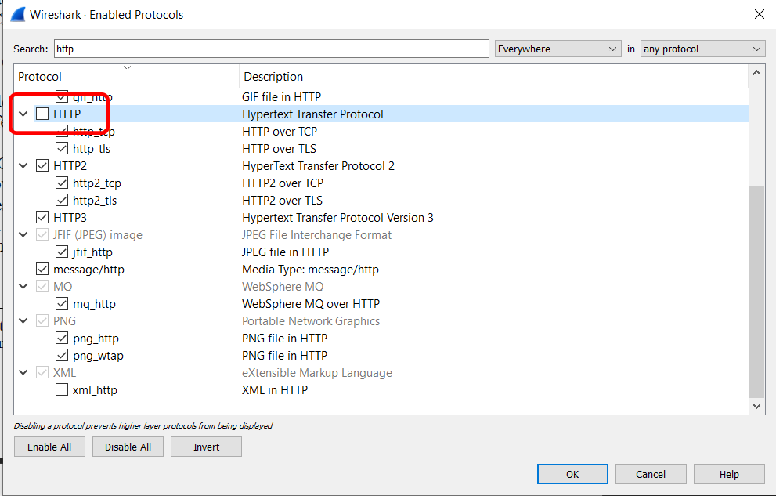

1. **What is the sequence number of the TCP SYN segment that is used to initiate the TCP connection between the client computer and gaia.cs.umass.edu What is it in the segment that identifies the segment as a SYN segment?**

Sequence number: 0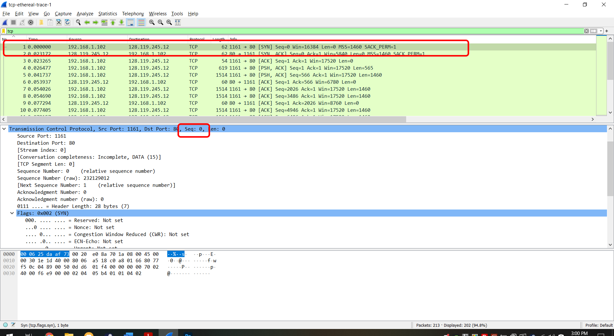

Identify segment as SYN: The flag for SYN is 1/set

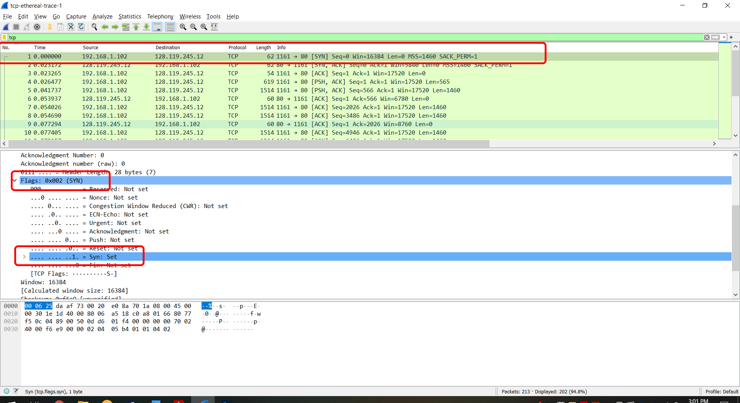

1. **What is the sequence number of the SYNACK segment sent by gaia.cs.umass.edu to the client computer in reply to the SYN? What is the value of the Acknowledgement field in the SYNACK segment? How did gaia.cs.umass.edu determine that value? What is it in the segment that identifies the segment as a SYNACK segment?**

Sequence number (relative): 0

Sequence number (raw): 883061785

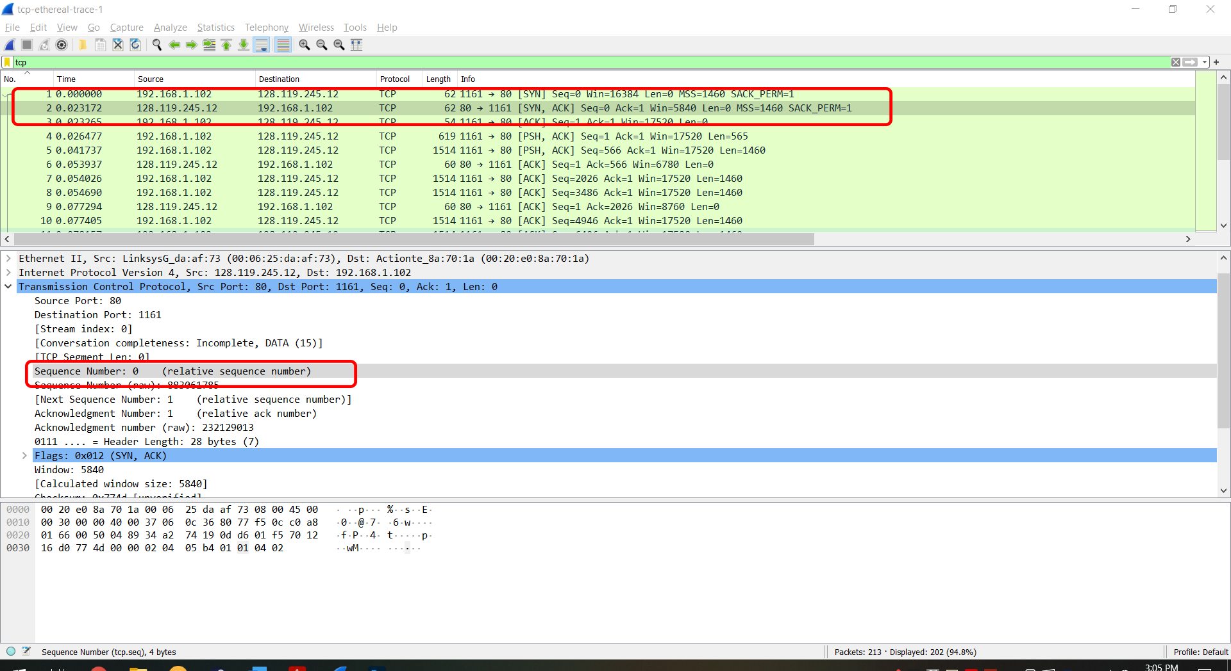

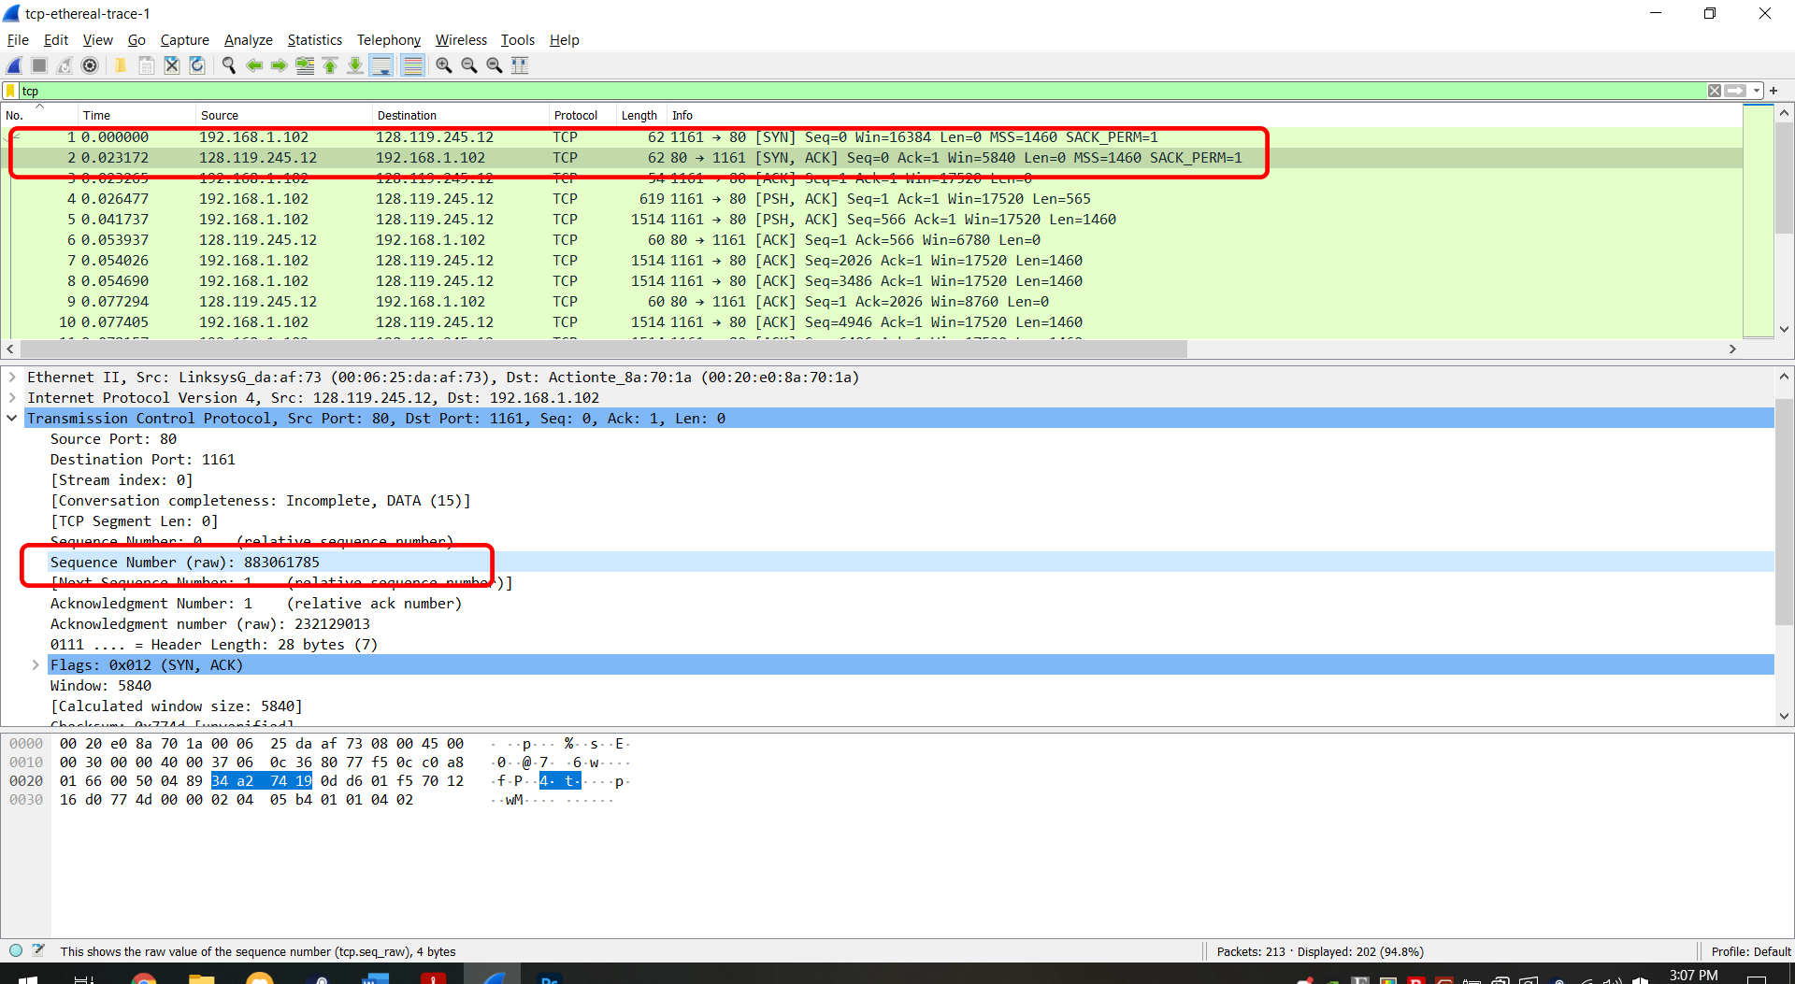

Value of the acknowledgement field: 1/set

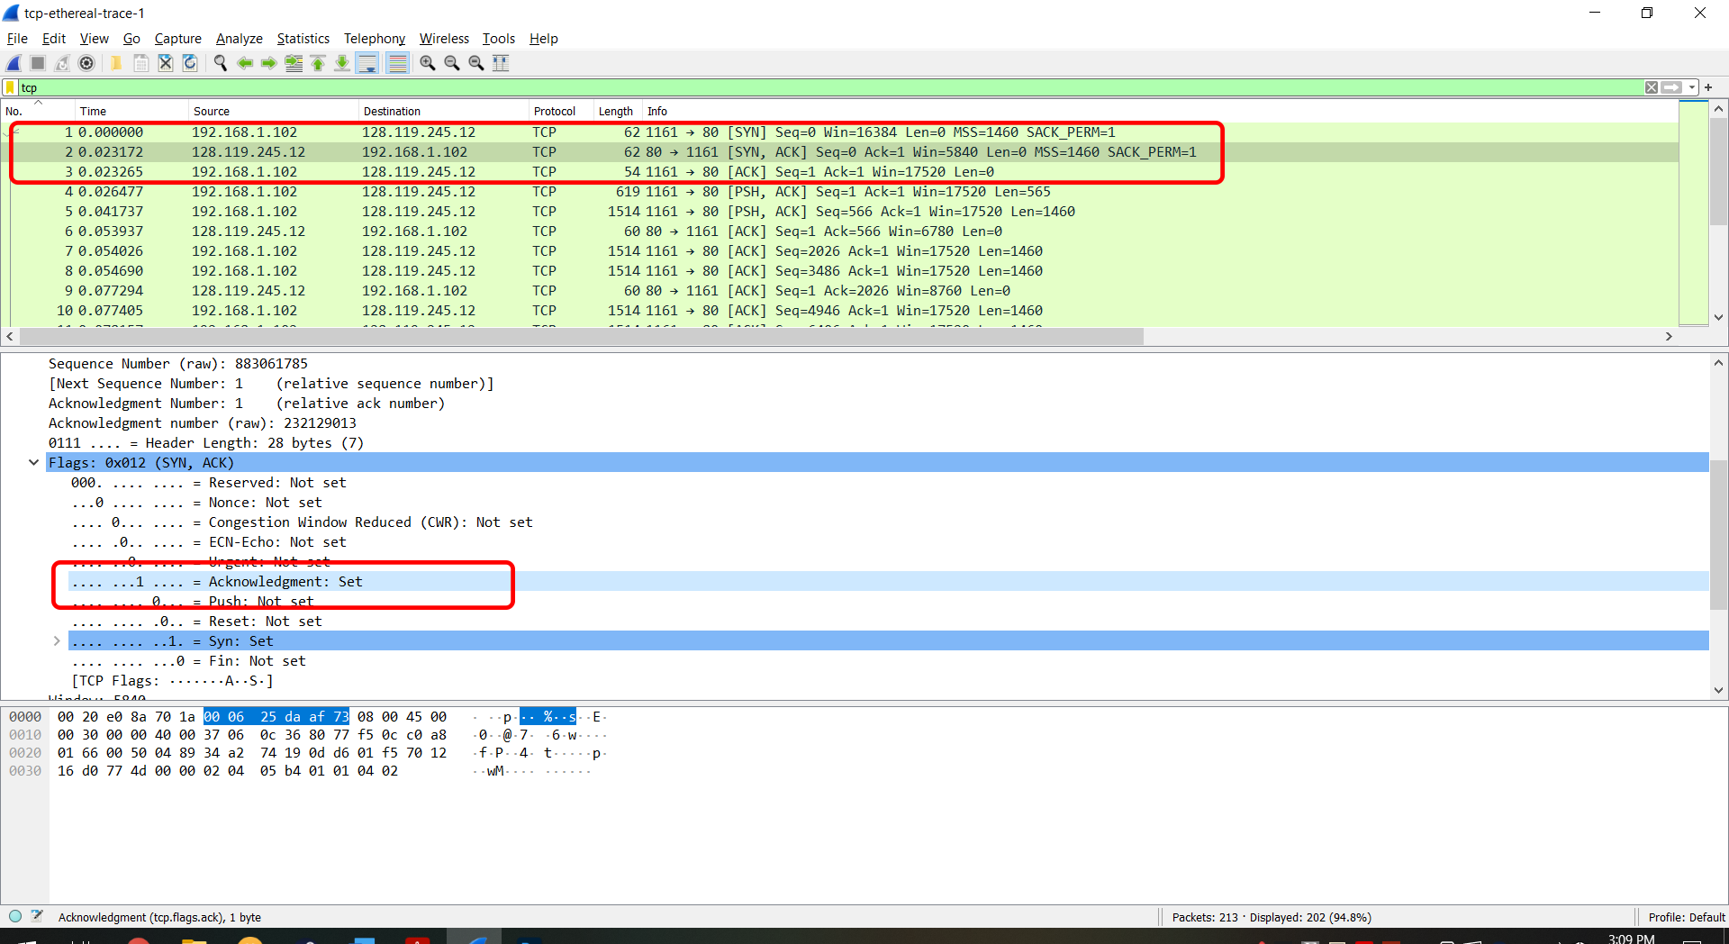

How was it determined?

The value of the acknowledgement field was determined as 1/set because the server, or gaia.cs.umass.edu adds 1 to the sequence number given by the client. The sequence number given by the client here was 0, so the server added 1 and it became 1.

Segment that identified segment as SYNACK segment?

Since both the SYN flag (SYN) and the acknowledgement flag (ACK) are 1/set they combine and form SYNACK as by the abbreviations.

1. **What is the sequence number of the TCP segment containing the HTTP POST command? Note that in order to find the POST command you’ll need to dig into the packet content field at the bottom of the Wireshark window, looking for a segment with a “POST” within its DATA field.**

Sequence number of the TCP segment containing HTTP POST (relative): 1

Sequence number of the TCP segment containing HTTP POST (raw): 232129013

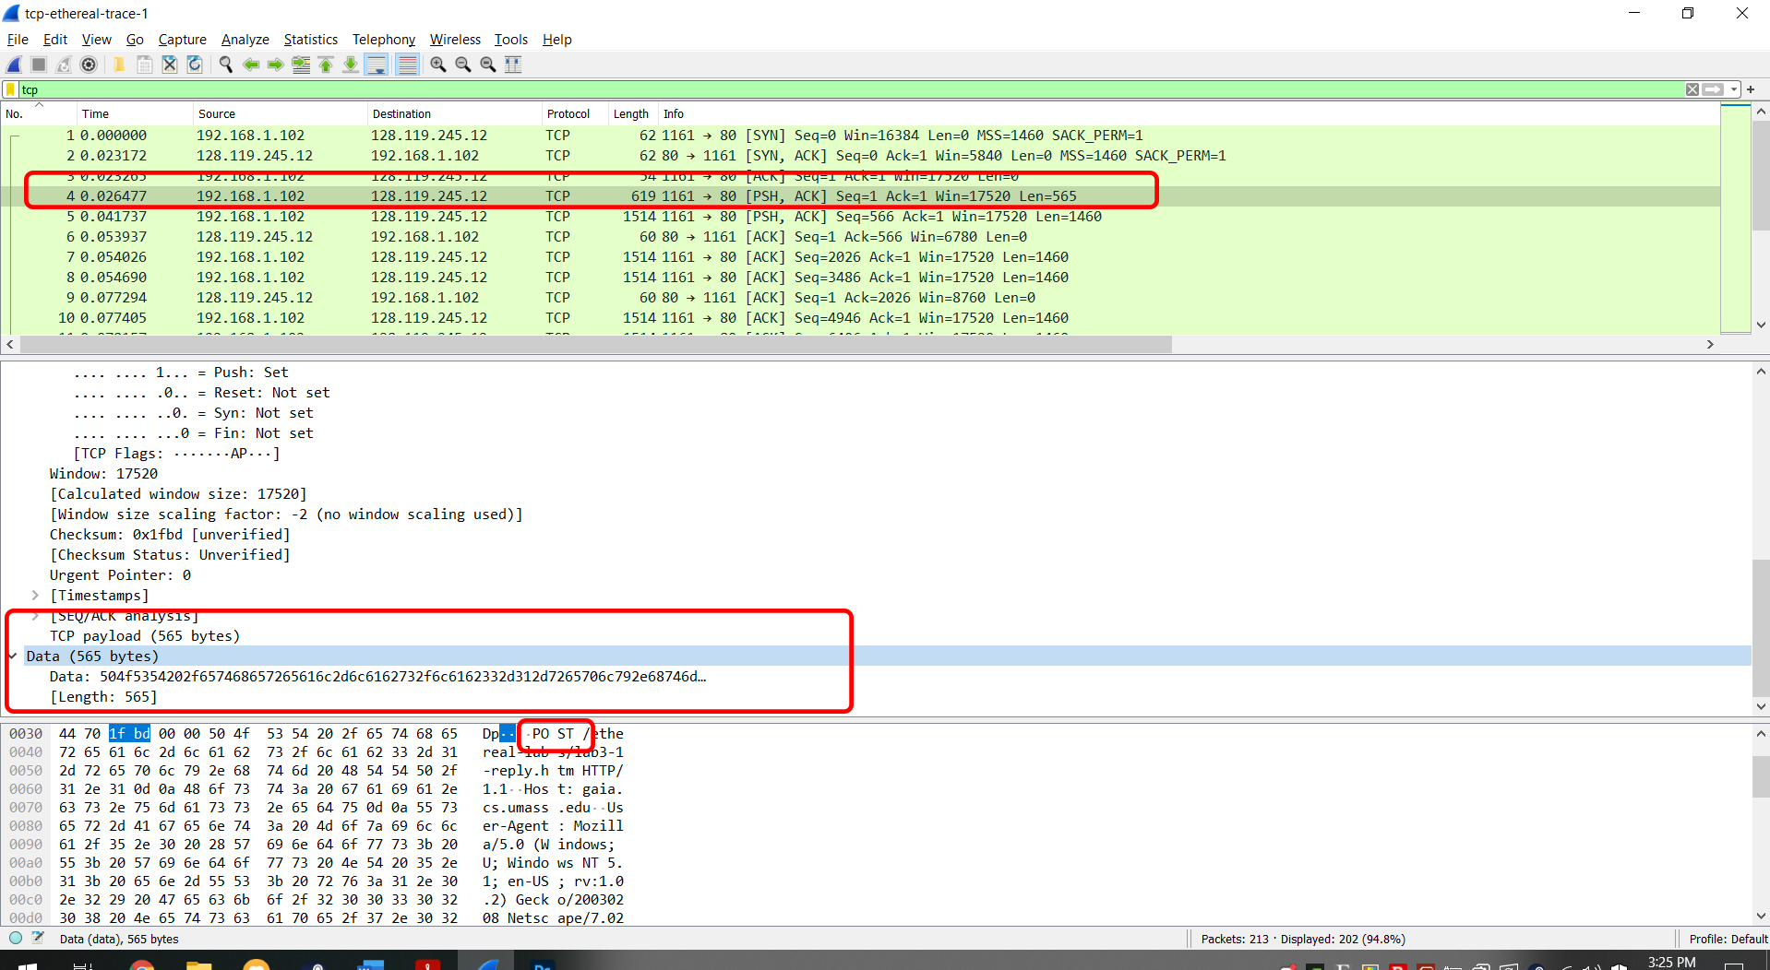

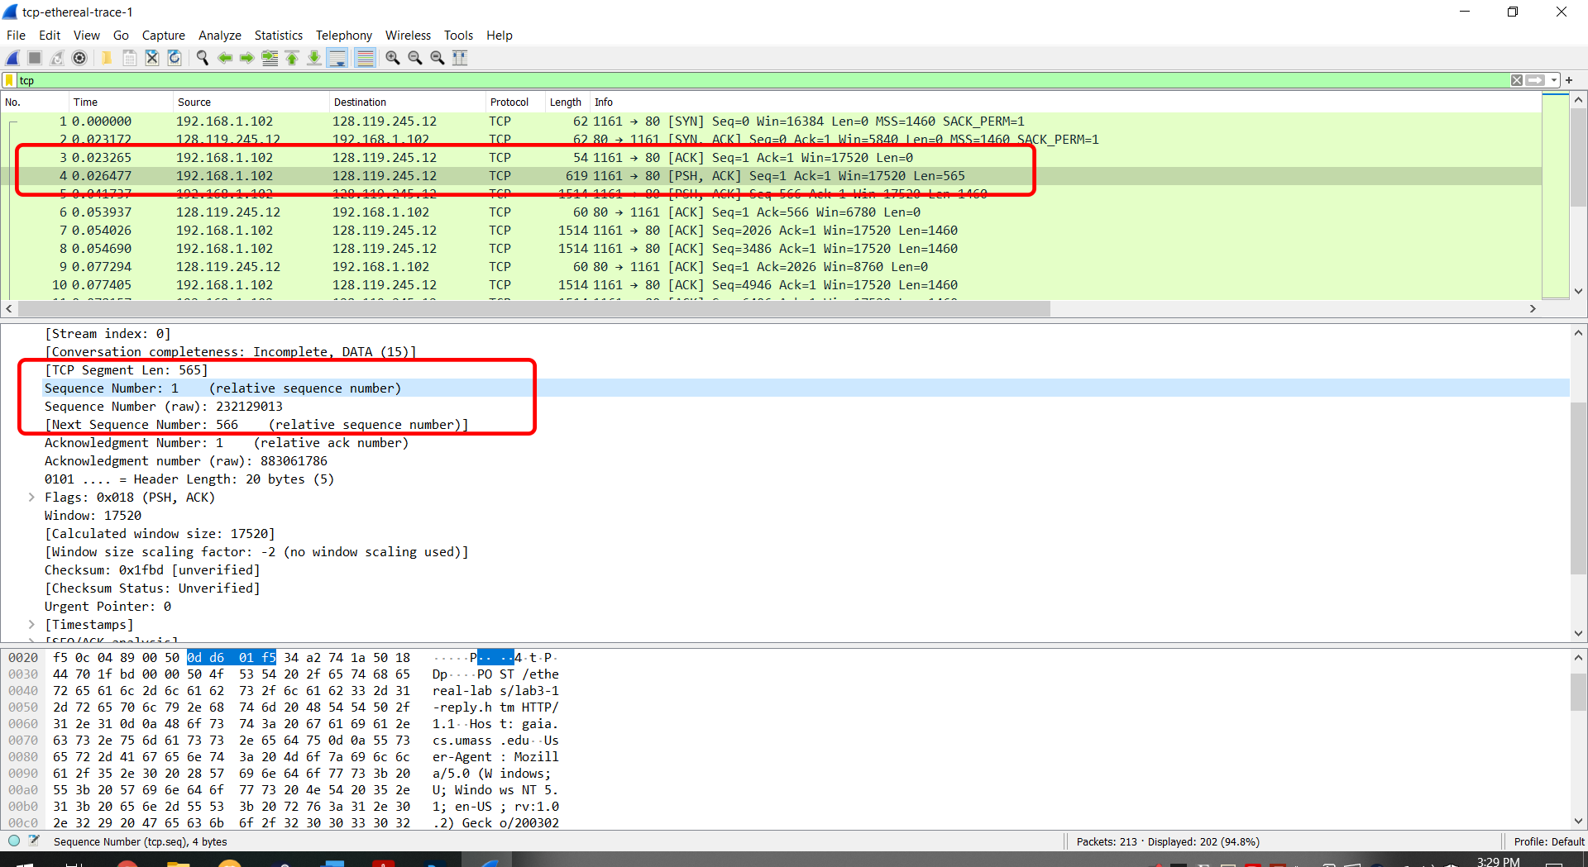

1. **Consider the TCP segment containing the HTTP POST as the first segment in the TCP connection. What are the sequence numbers of the first six segments in the TCP connection (including the segment containing the HTPP POST)? At what time was each segment sent? When was the ACK for each segment received?**

Segment 1 – Packet 4 – sequence 1 – sent 0.026477 – Packet 6 ack 0.053937

Segment 2 – Packet 5 – sequence 566 – sent 0.041737 – Packet 9 ack 0.077294

Segment 3 – Packet 7 – sequence 2026 – sent 0.054026 – Packet 12 ack 0.124085

Segment 4 – Packet 8 – sequence 3486 – sent 0.054690 – Packet 14 ack 0.169118

Segment 5 – Packet 10 – sequence 4946 – sent 0.077405 – Packet 15 ack 0.217299

Segment 6 – Packet 11 – sequence 6406 – sent 0.078157 – Packet 16 ack 0.267802

Timings sent with sequence:

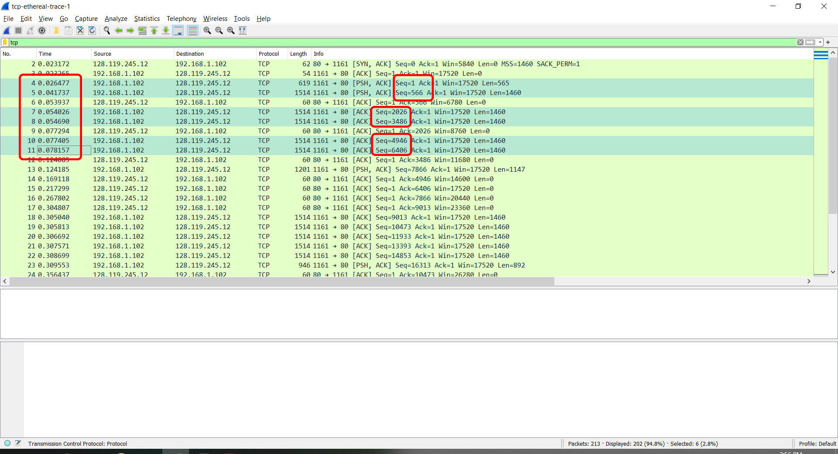

Timings acknowledged:

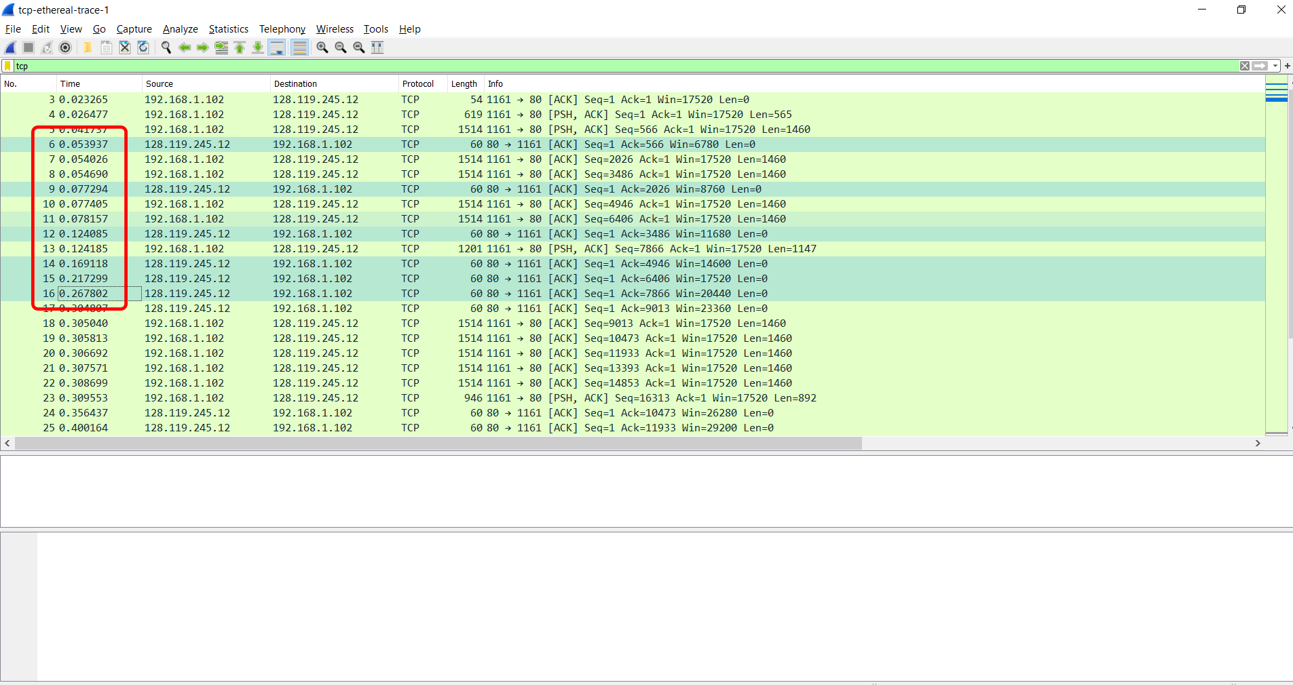

1. **What is the length of each of the first six TCP segments?**

Segment 1 – Packet 4 – 565 bytes

Segment 2 – Packet 5 – 1460 bytes

Segment 3 – Packet 7 – 1460 bytes

Segment 4 – Packet 8 – 1460 bytes

Segment 5 – Packet 10 – 1460 bytes

Segment 6 – Packet 11 – 1460 bytes

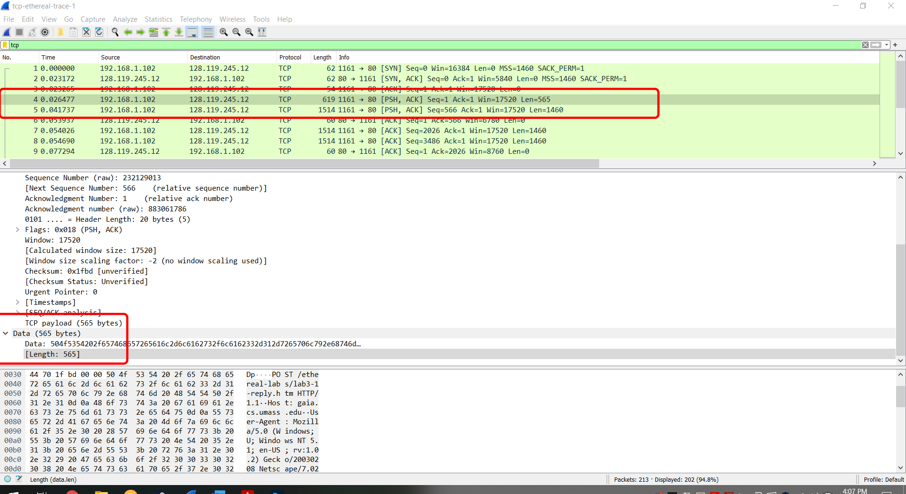

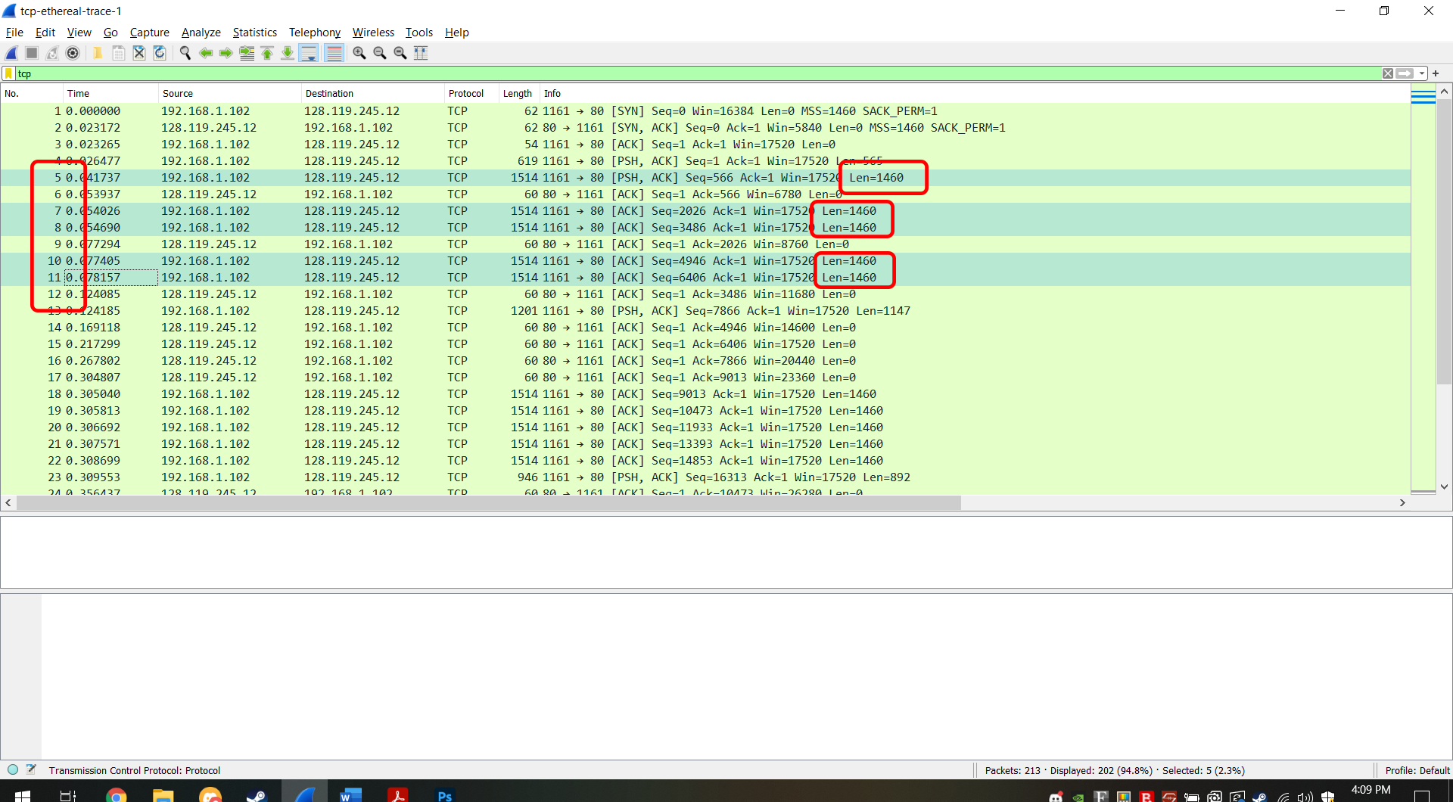

I pledge that on all academic work that I submit, I will neither give nor receive unauthorized aid, nor will I present another person's work as my own.

Dalton Murray